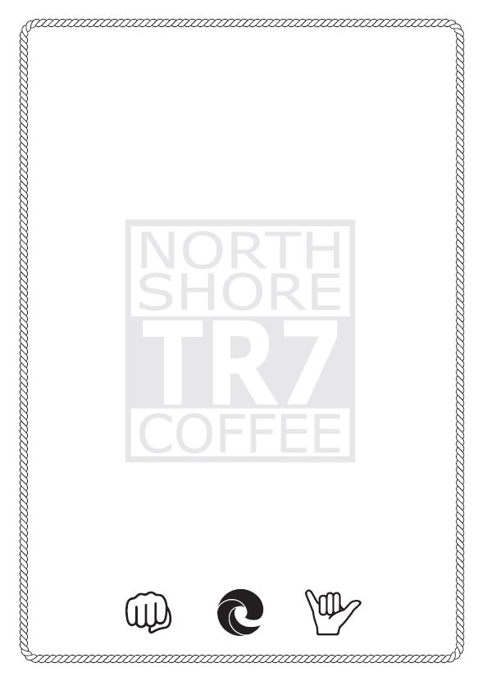

BREAKFAST

Pavilion Bakery Pastries 3

CAKES

Banana Bread with spelt flour & dark chocolate 2.5

Low sugar Feel Good Flapjacks 2.5

Super Blueberry Large Muffins 3

Rhubarb Polenta Cake 3.5

Protein Balls 1.5

**MENU**